**Exercise 1: Inventory Management System.**

**Why Data Structures & Algorithms Are Essential**

* Enable fast data access and manipulation.
* Support real-time updates and dynamic data handling.
* Ensure consistency and avoid data duplication.
* Optimize resource usage and performance.

**Suitable Data Structures for Inventory Management**

* ArrayList - Suitable for small-scale inventory with minimal complexity.
* HashMap - Ideal for large inventories requiring fast lookup, insert, update, and delete.
* TreeMap - Useful when data needs to be maintained in a sorted order by keys.

**Output**

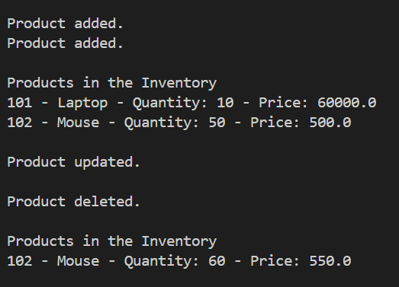

**Time Complexity Using HashMap**

* Add Product – O(1)
* Update Product – O(1)
* Delete Product – O(1)
* Search Product – O(1)

### Optimization Tips:

* Use HashMap for fast access by productId.
* If you need sorted access, use TreeMap (but with O(log n) operations).
* Use indexing if storing in a database later for even better performance with SQL queries.